Informal English

I’m going out tonight. = I’m gonna out tonight.
I’ve got to get home soon. = I gotta get home soon.
You are not coming to my party. = You ain’t coming…
You don’t know me. = You dunna know me.
I want to see you later. = I wanna see you later.
I shan’t be there. = I shanna be there.
I can’t go to your party. = I canna go to your party.

Internet Chat Abbreviations

? - Please explain
@ - at
2 - to, too
2L8 - Too Late
2nite - tonight
2U2 - To you too
4 - for
ASL? - Age, Sex, Location?
AYT? - Are You There?
B4 - Before
B/C - Because
BF - Boyfriend
GF - Girlfriend
BTW - By The Way
C - see
CIO - Check It Out
CU - See You
Cud - could
CYA - See You
DIY - Do It Yourself
DL or D/L – Download
Dnr - dinner
F2F - Face to Face
FAQ - Frequently Asked Questions
GGL - Giggle
H&K - Hugs and Kisses
HAND - Have A Nice Day
IC - I See
J/K, JK - Just Kidding
KISS - Keep It Simple, Stupid
L8 - late
L8R - Later
LOL - Laughing Out Loud
M8 - Mate
N2M - Not too Much
OMG - Oh My God
PLZ - Please
ROFL - Rolling On Floor Laughing
ROTFL - Rolling On The Floor Laughing
TGIF - Thank God It's Friday
TX, TNX - Thanks
TYVM - Thank You Very Much
Tom - tomorrow
U - you
UL or U/L - Upload
UR - You are, your
W8 - Wait
W8AM - Wait A Minute
W/O - Without
YW - You're Welcome

- Can you read these messages?
“R U coming 2night? B here B4 8. Will w8 4 U.
C U l8er.”

“Cud I c u 2nite 4 dnr @ 7?”

- Write a text message to your friend using some of the abbreviations:
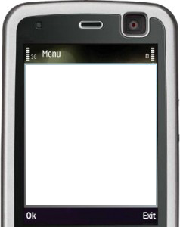

- Work with your partner to create some TNGAs (The New Great Abbreviations). Think of the phrases or words in English you use very often and TNGAs will help you to save time or texting space. Be ready to advertise these abbreviating to the other groups.

